**A**

**Project Report**

**On**

**Decision Review System**

**Submitted for the award of degree of**

**Bachelor of Technology**

**In**

**Computer Science & Engineering**

By

**Saksham** (20020004088)

**Sachi** (20020004087)

**Under the Supervision of**

**Ms. Vaishali**



**Department of Computer Science &Engineering**

**Satyug Darshan Institute of Engineering & Technology**

**FARIDABAD-121002**

**Dec 2022**

**DECLARATION**

I hereby declare that the project entitled “DECISION REVIEW SYSTEM ” submitted for the B. Tech. (CSE) degree is my original work and the project has not formed the basis for the award of any other degree, diploma, fellowship orany other similar titles.

Place: Signature of the Student

**CERTIFICATE**

This is to certify that the project titled “ Decision Review System ” is the bona fide work carried out by Saksham Kashyap , Sachi Mittal students of B.Tech (CSE) of Satyug Darshan Institute of Engineering and Technology, Bhupani (Faridabad) affiliated to JC BOSE University, Faridabad, Haryana(India) in partial fulfillment of the requirements for the award of the degree of Bachelor of Technology (Computer Science and Engineering ) and that the project has not formed the basis for the award previously of any other degree, diploma, fellowship or any other similar title.

Place: Signature of the Guide

**ABSTRACT**

A fair decision is crucial in any sport to give justice to the game. Any wrong decision due to human misperception may fate the result of the game. Computer vision and Image processing techniques use multiple cameras for demonstration. This project focuses on a system which helps in making the decisions to assist the umpire in taking the decisions such as determination of winner in a race, not- out/out in cricket, foul or goal in football etc. with just the help of smartphone camera of good quality. The Decision Review System (DRS) which is to be developed in this project aims to give decisions like run-out and stumpout. Tkinter will be used to develop the Graphical User Interface (GUI) of DRS. Tools such as OpenCV library, Python Imaging Library, Imutils will be used for the implementation.

**ACKNOWLEDGEMENT**

We take this opportunity to thank all those magnanimous persons who rendered their full services to our work.

It’s with lot of happiness we are expressing gratitude to our guide Ms. Vaishali ,CSE Department, for timely and kind help, guidance and providing us with most essential materials required for the completion of this project. We are very thankful to our guide for her indomitable guidance. Her inspiration up to the last moment had made things possible in a planned manner.

We also thank our teaching faculties for the cooperation extended for the successful completion of the project.

Finally, we thank each and everyone who helped to complete our project work with their Cordial support.

**Table of Contents**

Title Page 01

Declaration of the Student 02

Certificate of the Guide 03

Abstract 04

Acknowledgement 05

Table of contents 06

1. INTRODUCTION 07
2. SYSTEM ANALYSIS 08
3. SYSTEM REQUIREMENT 09
4. MODULE DESCRIPTION 10
5. LANGUAGE USED 13
6. User Interface Design 16
7. Preliminary Product Description 17
8. Appendice 20
9. RESULTS / OUTPUT 21
10. CONCLUSION AND FUTURE SCOPE 22
11. REFERENCES 23

**INTRODUCTION**

With technology taking over every aspect of life, it was only a matter of time before it was utilized to the advantage of sports.

Technology in sport is used with an objective to eliminate human errors that may have earlier affected the course of the game drastically.

The Decision Review System was introduced across various sports, to give the players an opportunity to review such errors from the on field umpire.This project identifies and examines the use of officiating technology and it impact across different sports such as badminton, rugby, tennis and cricket. In addition to this, statistics collected within various sports have proved time and again that umpiring decisions have been more accurate with DRS than without. It is silly to argue that we should not have DRS unless it has 100% accuracy—you anyway cannot get 100% accuracy without using technology.

It is enough that DRS improves the accuracy percentage—as it doubtless has, from 90.3% to 95.8%—for there to a strong case for its use. Furthermore, the DRS also has other things going for it.As the Guardian’s Rob Smythe has pointed out, it is changing the game in some fundamental ways, and definitely for the better. It has made the game even more competitive and fair

Judgement .

**SYSTEM ANALYSIS**

System analysis is the process of gathering and interpreting facts, diagnosing problems and using the information to recommend improvements on the system. System analysis is a problem solving activity that requires intensive communication between the system users and system developers.

System analysis or study is an important phase of any system development process. The system is viewed as a whole, the inputs are identified and the system is subjected to close study to identify the problem areas. The solutions are given as a proposal. The proposal is reviewed on user request and suitable changes are made. This loop ends as soon as the user is satisfied with the proposal.

**SYSTEM REQUIREMENT**

⁕ The Basic System Requirements are as follows :-

**Hardware Configuration**

1. PROCESSOR : Intel I3 Processor
2. RAM REQUIRED : Minimum 4 GB Ram
3. SYSTEM TYPE : 32- Bit OPERATING SYSTEM

**Software Requirements**

1. OpenCV Library - 32- or a 64-bit computer, Windows 7,10or 11, macOS X 10.11 or higher, or Linux RHEL 6/7, Python2.7, 3.4, 3.5 or 3.6
2. Tkinter (8.6. 11)

iii. Imutils - Open CV Library, Python 2.7 or 3.Visual Studio Code IDE (1.61.1)

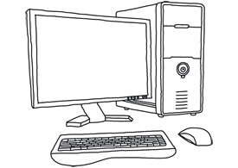

**AIM’s** **and** **OBJECTIVE’s**

Our aim is to create a Decision review system (DRS) with the objective of eliminating the howler – the poor decision taken due to nuances missed with the naked eye, which with assistance of this technology can be avoided. Our project will provide aid with decisions like run-out, stumpout,net-cross,declaring a winner etc. Tkinter will be used to develop the Graphical User Interface (GUI) of DRS. To detect the decision or occurrence of event of the sport from the video we will be optimizing and using various functions such as frame subtraction using an inbuilt python module called OpenCV library.

**LITERATURE SURVEY**

**⁕ Umpire Decision Review System in Cricket**

This paper aims to produce a very cost effective and affordable computer mechanism that supports and facilitates the cricket umpire, runs at a low budget, has lower technical (software and hardware) requirements, and can be used in cricket tournaments at local district level, this indeed will train the network as well as improve the efficiency of the game from a grass root level.

The module uses tools like Python, Tkinter for GUI, Pillow, OpenCV and Imultis packages for Python. In this project specifically, live feed of the instance can be fed through the camera as an input stream for the software and thus decisions can be carried out in an instance, for the live audience. Ultimately saving precious time. Without any fancy equipment and with the help of just a computer system and a camera this system can run efficiently, thus making it compatible for all scale tournaments.

This project is only an infant and there is always room for various kinds of improvement and modifications.

**Decision Review System in Cricket**

This paper suggests that the most common instances of referrals are for caught behind and Leg Before Wicket (LBW).As the final decision rides on chance of agreement of the field umpire along with, the DRS algorithms since this technology predicts the nature of the trajectory of the delivery and such factors are dealt in very small measurements (in millimeters). Various errors included may change the final result for the same delivery if replayed again. The paper put forth the main idea that is to have a continuous real time feed clicked from the six cameras strategically placed in the stadium each operating at the specific frame rate which is enough to capture the pitched delivery to provide data points for mapping the virtual trajectory of the ball. Though, there is always a question of the accuracy with which the technology works as its decision cannot be referred again and is considered final. Hence, the accuracy of the technology used is limited to a certain range, but along with the human intervention in the decision making, this review system is bound to be the perfect solution to such a problem.

**Decision Review system in Tennis**

All Grand Slam tournaments of tennis provide line review system which uses Hawk-Eye ball tracking system. The players can use this system to evaluate debatable line calls.All Hawk-Eye systems are based on the principles of triangulation using visual images and timing data provided by a number of high-speed video cameras located at different locations and angles around the area of play. The tennis hawk eye system uses up to ten cameras. The system rapidly processes the video feeds from the cameras and ball tracker. The system uses something called data store which is used to store a 3D blue-print model of the playing area/ court and also stored in it are the rules of the game.

**Decision Review System in Football**

Decision Review system in Football comprises of various systems such as smart ball system, Goal Ref System, Hawk eye System, etc. The system which has had a very successful trial and is the leading candidate out of all the other system is the Hawk eye system. Primarily used in the English Football league, Premier League the Hawk Eye system uses three cameras targeted on every goal-line, and each of them take video footage at 600 frames per second. Hawk-Eye has the means to grant a conclusive decision on whether the football has fully crossed the goal line or not and transfer this information to the main referee in less than a second.

**PROPOSED SYSTEM**

Traditionally, in various sports the final judgement is given by the referee or the umpire. While usually most of these decisions are correct, often there are discrepancies behind these decisions since human judgement is involved which has the potential to change the final result of the game. Our System is basically an aid to the umpire in case of such discrepancies where in only a good quality camera and a system to operate the software is needed. What this human aid does is, it operates on frame rate to give a clear picture of the exact moment where the decision needs to take place and the final call is given by the referee themselves.

**For the module :**

Our project will be implemented using Python and Tkinter, OpenCV library, Python Imaging Library, Imutils, Pillow module etc. Decisions like stump out, run out etc. can be decided by altering the source video’s frame rate for the which, we will be optimizing and using frame subtraction using OpenCV library.

**1** **GUI of DRS:**

Tkinter is used to make GUI of the Decision Review System and various computer vision algorithms that give decisions based on different criteria. Python offers multiple options for developing GUI (Graphical User Interface). Out of all the GUI methods, Tkinter is the most commonly used method. Being a Python binding to the Tk GUI toolkit, it gives standard Python interface to the Tk GUI toolkit, and is Python's de facto standard GUI. Tkinter also includes standard GNU/Linux, Microsoft Windows and mac OS installs of Python.

**2 Frame Subtraction:**

Frame subtraction will be done using OpenCV (OpenSource Computer Vision Library) which is a library of programming functions mainly aimed at real-time computer vision. OpenCV is an open-source library which is very useful for computer vision applications such as video analysis, CCTV footage analysis and image analysis. OpenCV supports a wide variety of programming languages like Python, C++, Java.It can process images and videos to identify objects, faces, or even the handwriting of a human. OpenCV is written by C++ and has more than 2,500 optimized algorithms. When we create applications for computer vision that we don’t want to build from scratch we can use this library to start focusing on real world problems. There are many companies using this library today such as Google, Amazon, Microsoft and Toyota. Many researchers and developers contribute.We can easily install it in any OS like Windows, Ubuntu and Mac OS. With reference to our project, OpenCV library will be majorly used to bring changes to the frame i.e., increasing or decreasing the frame speed.

**3 Python Imaging Library:**

Python Imaging Library (expansion of PIL) for which Pillow module is to be installed, is the de facto image processing package for Python language. It incorporates lightweight image processing tools that aids in editing, creating and saving images and with respect to our project, it will load images from an array.

**4 Imutils Module:**

Imutils which is basically a series of convenience functions to make basic image processing functions such as translation, rotation, resizing, skeletonization, and displaying images easier with OpenCV will also be used for the implementation.

**DESIGN OF THE SYSTEM**

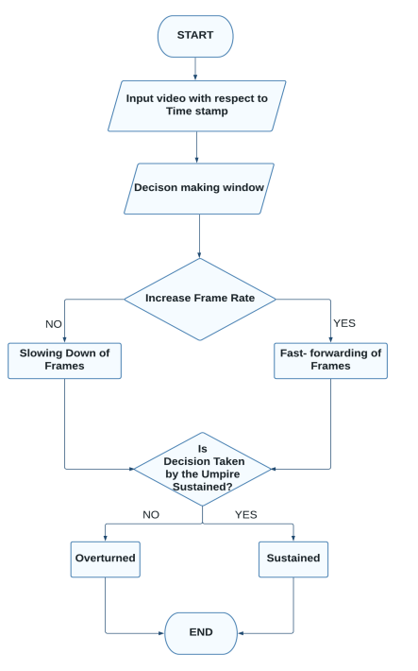

In the system, the video will be added according to the time frame where in the decision making is required. Then the sport is to be selected accordingly following which a decision window pop-up will appear where there will be options to slow or make the video go faster by altering the frame rate and thus it will be decided if the decision made by the umpire is to be sustained or overturned. System Architecture.

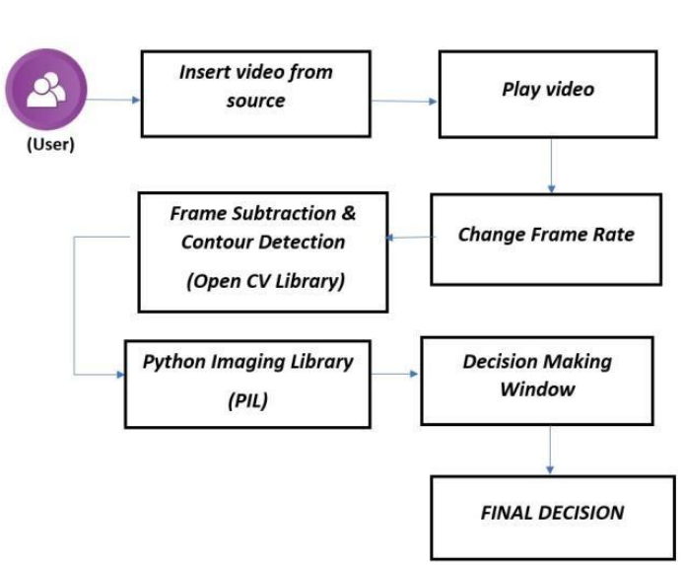

The project has been implemented using tools like Tkinter for GUI, Pillow, and OpenCV. Tkinter is a GUI framework thatis built into the Python standard library that has been used for the front end. For the backend the python programming language has been used. At first the user will be selecting a sport for which the decision has to be made. Then a video will be inserted from the source destination. Once inserted we can play the video with different frame rates available. This could be done using various modules and tools as mentioned. OpenCV is a huge open-source library for various sectors which has been primarily used for image processing. It will be used to process images and videos.

**Preliminary Product Description**

The first step in the system development life cycle is the preliminary investigation to determine the feasibility of the system. The purpose of the preliminary investigation is to evaluate project requests. It is not a design study nor does it include the collection of details to describe the business system in all respect. Rather, it is the collecting of information that helps committee members to evaluate the merits of the project request and make an informed judgment about the feasibility of the proposed project.

**Analysts working on the preliminary investigation should accomplish the following objectives:**

• Clarify and understand the project request

• Determine the size of the project.

• Assess costs and benefits of alternative approaches.

• Determine the technical and operational feasibility of alternative approaches.

• Report the findings to management, with recommendations outlining the

acceptance or rejection of the proposal.

• Benefit to Organization

The organization will obviously be able to gain benefits such as savings in

operating cost, reduction in paperwork, better utilization of human resources and more presentable image increasing goodwill.

• The Initial Cost

The initial cost of setting up the system will include the cost of hardware software

(OS, add-on software, utilities) & labour (setup & maintenance). The same has to bear by the organization.

• Running Cost

Besides, the initial cost the long term cost will include the running cost for the

system including the AMC, stationary charges, cost for human resources, cost for update/renewal of various related software.

• Need for Training

The users along with the administrator need to be trained at the time of

implementation of the system for smooth running of the system. The client will provide the training site.

We talked to the management people who were managing a the financial issues of the center, the staff who were keeping the records in lots of registers and the reporting

manager regarding their existing system, their requirements and their expectations from the new proposed system. Then, we did the system study of the entire system based on their requirements and the additional features they wanted to incorporate in this system.

Reliable, accurate and secure data was also considered to be a complex task

without this proposed system. Because there was no such record for keeping track of all the activities, which was done by the Online Food Ordering System on the daily basis.

The new system proposed and then developed by me will ease the task of the

organization in consideration. It will be helpful in generating the required reports by the staff, which will help them to track their progress and services.

Thus, it will ease the task of Management to a great extent as all the major

activities to be performed, are computerized through this system.

**APPENDICES**

Appendix A - Project Document :

The project documentation for an application for online commodity and delivery system detailed project documentation

Candidate Name: Saksham Kashyap

Design and implementation of a Decision Review System

Course of Study: Btech Computer Science